**Project Report Format**

1. **INTRODUCTION** 
   1. Project Overview
   2. Purpose
2. **LITERATURE SURVEY**
   1. Existing problem
   2. References
   3. Problem Statement Definition
3. **IDEATION & PROPOSED SOLUTION**
   1. Empathy Map Canvas
   2. Ideation & Brainstorming
   3. Proposed Solution
   4. Problem Solution fit
4. **REQUIREMENT ANALYSIS**
   1. Functional requirement
   2. Non-Functional requirements
5. **PROJECT DESIGN**
   1. Data Flow Diagrams
   2. Solution & Technical Architecture
   3. User Stories
6. **PROJECT PLANNING & SCHEDULING**
   1. Sprint Planning & Estimation
   2. Sprint Delivery Schedule
   3. Reports from JIRA
7. **CODING & SOLUTIONING (Explain the features added in the project along with code)**
   1. Feature 1
   2. Feature 2
   3. Database Schema (if Applicable)
8. **TESTING** 
   1. Test Cases
   2. User Acceptance Testing
9. **RESULTS**
   1. Performance Metrics
10. **ADVANTAGES & DISADVANTAGES**
11. **CONCLUSION**
12. **FUTURE SCOPE**
13. **APPENDIX**

Source Code

GitHub & Project Demo Link

**Project Title: Real-Time Communication System Powered by AI for Specially Abled**

**Team ID: PNT2022TMID18207**

Team Leader : Thana Vignesh B N

Team Member1 : vishwaugh K

Team Member2: Prabhakar P

Team Member3: Pravin chandhar R

Team membe4:Karthik kumar K

Industry Mentor(s) Name : Divya

Faculty Mentor(s) Name : Amrutha S

Degree : Bachelor of Engineering

Branch : Electronics and Communication Engineering

College : Mepco Schlenk Engineering College

**INTRODUCTION**

### Objective:

The project aim is to develop an artificial intelligence model that converts sign language into a speech that can be understood by normal people

### 1.1Project Overview:

In our society, we have people with disabilities. The technology is developing day by day but no significant developments are undertaken for the betterment of these people. Communications between deaf-mute and a normal person has always been a challenging task. It is very difficult for mute people to convey their message to normal people. Since normal people are not trained on hand sign language. In emergency times conveying their message is very difficult. The human hand has remained a popular choice to convey information in situations where other forms like speech cannot be used. Voice Conversion System with Hand Gesture Recognition and translation will be very useful to have a proper conversation between a normal person and an impaired person in any language.

The project aims to develop a system that converts the sign language into a human hearing voice in the desired language to convey a message to normal people, as well as convert speech into understandable sign language for the deaf and dumb. We are making use of a convolution neural network to create a model that is trained on different hand gestures. An app is built which uses this model. This app enables deaf and dumb people to convey their information using signs which get converted to human-understandable language and speech is given as output.

**1.2PURPOSE**

The project deals on building an application which helps the specially challenged people to communicate between them and the common people. Communication between a person with hearing/speech impairment and a normal person has always been a challenging task. This application tries to reduce the barrier of communication by developing an assistive application for specially challenged people

**2.LITERATURE SURVEY**

1. Lance Fernandes; Prathamesh Dalvi; Akash Junnarkar; Manisha Bansode developed a Bidirectional Sign Language Translating system consists of a software system. It is named as a bidirectional system as it not only converts the sign language to speech via text conversion but also incorporates a system which translates the speech to the prescribed sign language with text conversion as the mediator

2. Zhen Xing Zhou; Vincent W. L. Tam; Edmund Y. Lam developd a deep learning framework named SignBERT, integrating the bidirectional encoder representations from transformers (BERT) with the residual neural network (Resnet), to model the underlying sign languages and extract spatial features for CSLR. We further propose a multimodal version of SignBERT, which combines the input of hand images with an intelligent feature alignment, to minimize the distance between the probability distributions of the recognition results generated by the BERT model and the hand images

3. Suhail Muhammad Kamal; Yidong Chen; Shaozi Li; Xiaodong Shi; Jiangbin Zheng put forth a survey which provides an overview of the most important work on Chinese sign language recognition and translation, discussed its classification, highlights the features explored in sign language recognition research, presents the datasets available, and provides trends for the future research.

4. Wei Pan; Xiongquan Zhang; Zhongfu Ye designed a new kind of skeletal feature called Multi-Plane Vector Relation (MPVR) to describe the video samples. and combined with the attention mechanism, we also use Attention-Based networks to distribute weights to the temporal features and the spatial features extracted from skeletal data

5. Jie Huang, Wengang Zhou, Houqiang Li, and Weiping we present an attention-based 3D-Convolutional Neural Networks (3D-CNNs) for SLR. The framework has two advantages: 3D convolutional networks learn spatio-temporal features from raw video without prior knowledge, and attention mechanism helps to select the clue

**2.1 References**

# 1.Convolutional Neural Network based Bidirectional Sign Language Translation System

2. Kshitij Bantupalli and Ying Xie, "American sign language recognition using deep learning and computer vision", 2018 IEEE International Conference on Big Data (Big Data),

# 3. SignBERT: A BERT-Based Deep Learning Framework for Continuous Sign Language Recognition

# 4. Technical Approaches to Chinese Sign Language Processing: A Review

5. A. S. Nikam and A. G. Ambekar, "Sign language recognition using image based hand gesture recognition techniques", 2016 Online International Conference on Green Engineering and Technologies (IC-GET), pp. 1-5, 2016.

**3. IDEATION & PROPOSED SOLUTION**

**3.1Empathy Map Canvas**

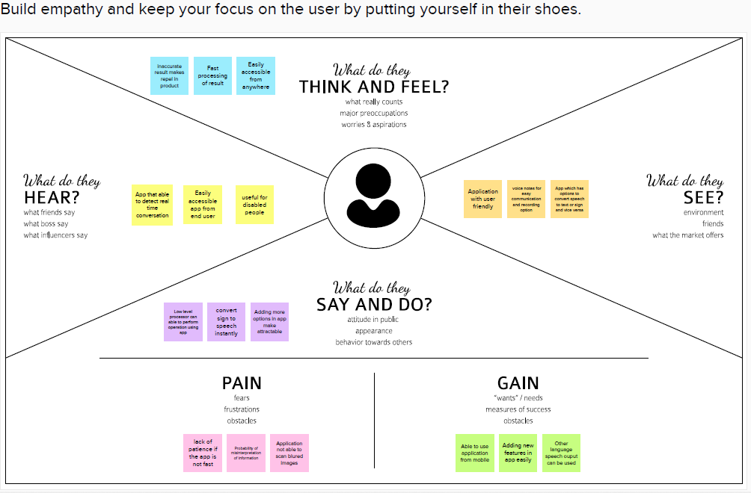

**3.2 Ideation & Brainstorming**

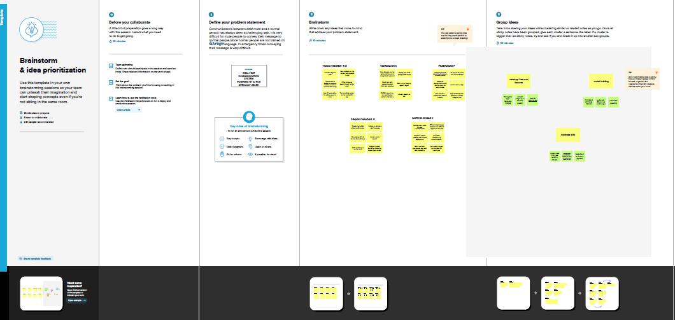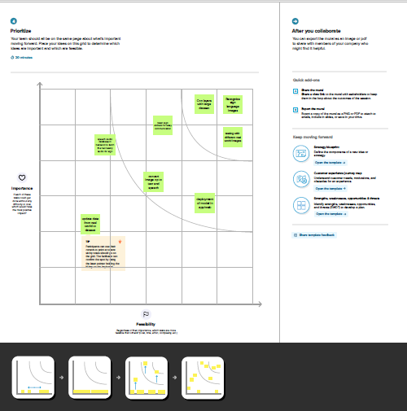

3.3 Proposed Solution

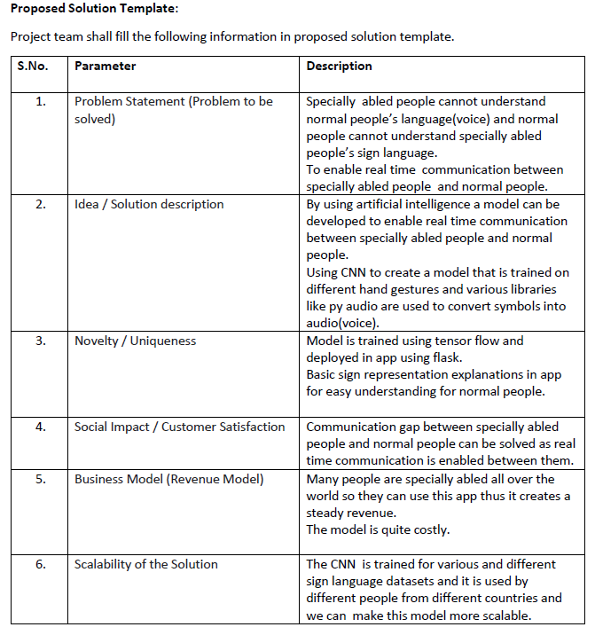

3.4 Problem Solution fit

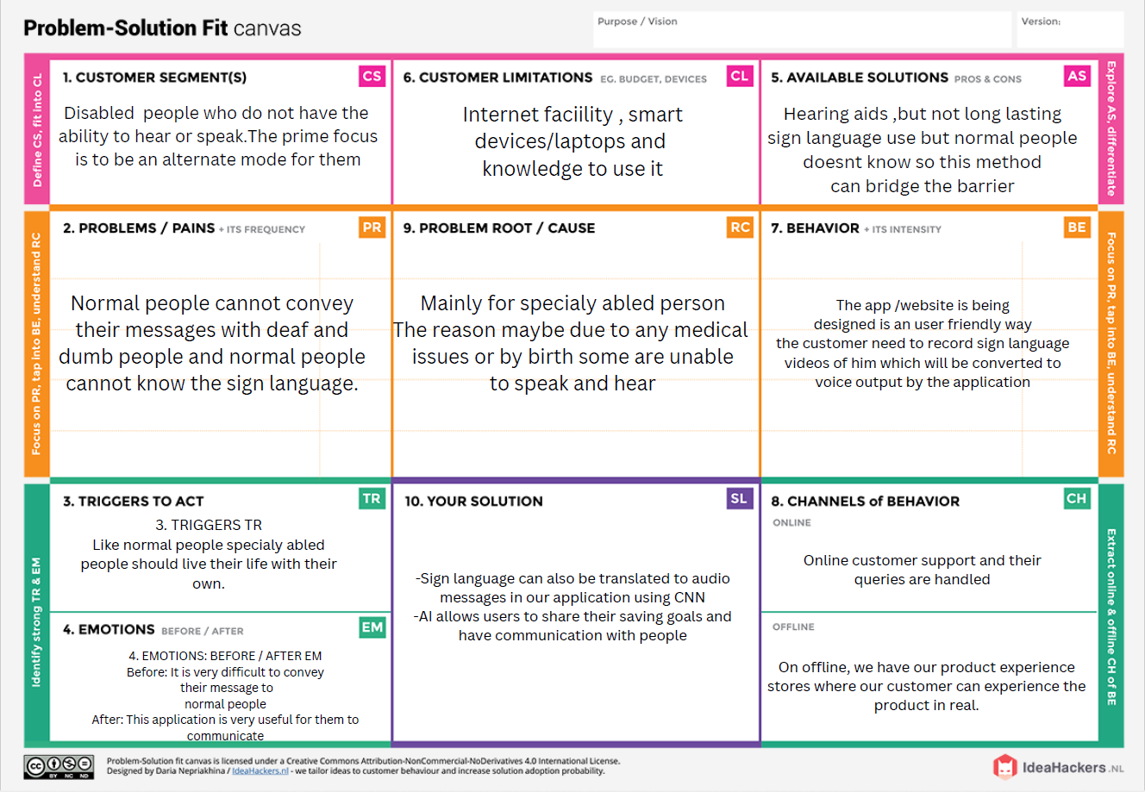

4. **REQUIREMENT ANALYSIS**

**4.1 Functional requirements**

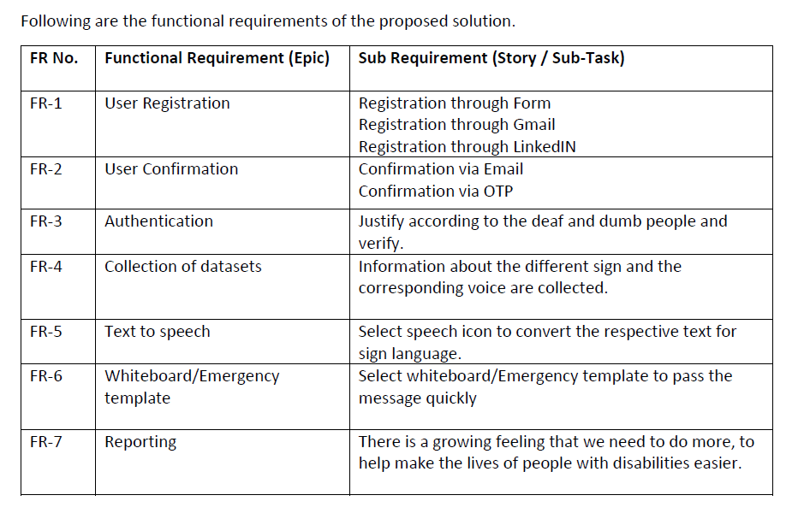

4.2 Non-Functional requirements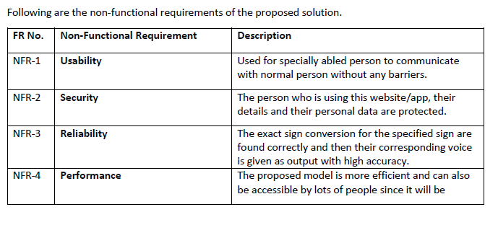

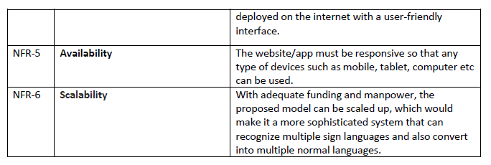

5. **PROJECT DESIGN**

**5.1 Data Flow Diagrams**

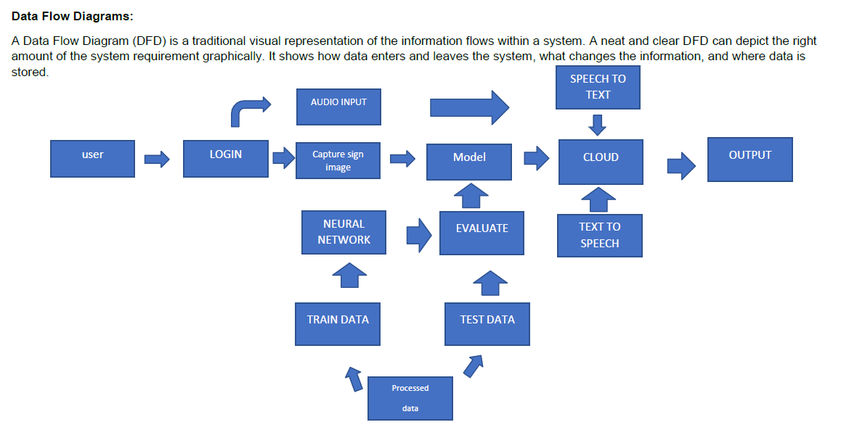

**5.2** Solution & Technical Architecture

**Technical architecture**

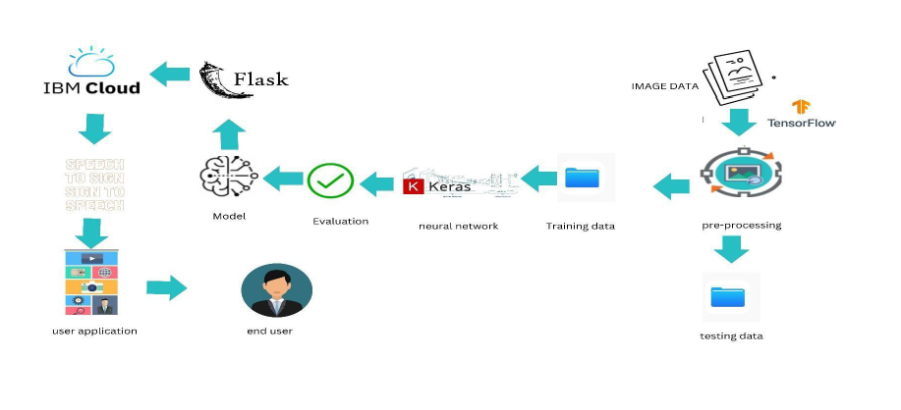

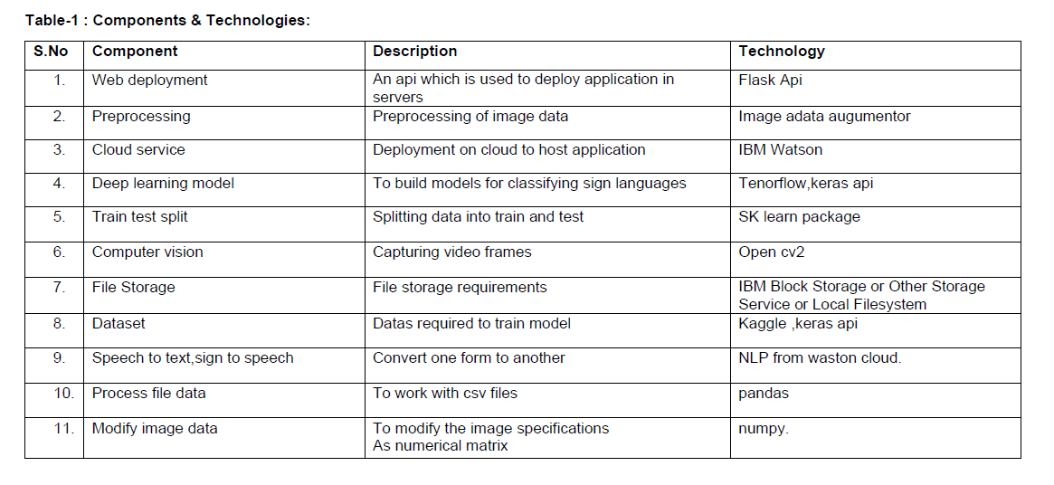

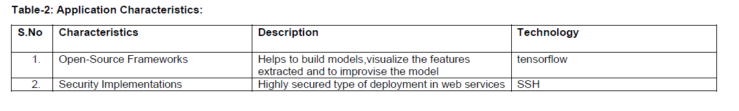 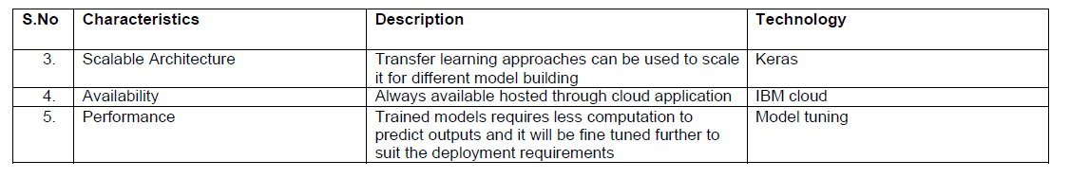

**5.3 User Stories**

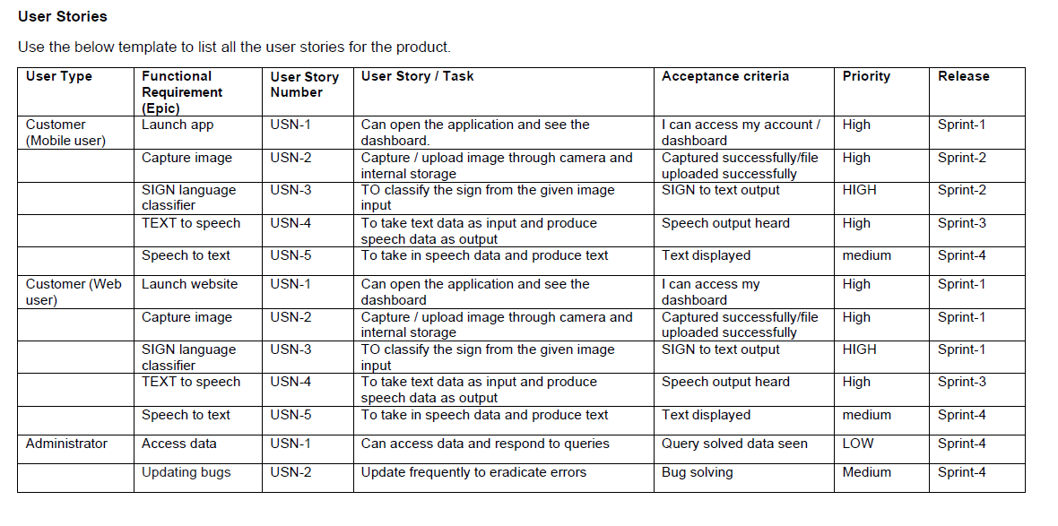

**6. PROJECT PLANNING & SCHEDULING**

**6.1 Sprint Planning & Estimation**

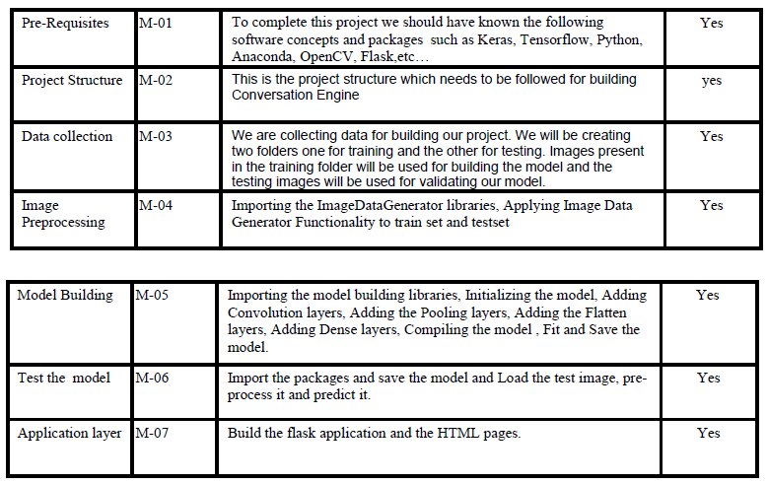

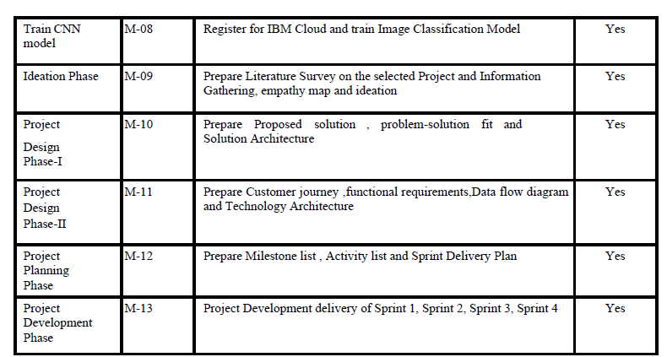

**6.2 sprint Delivery Schedule**

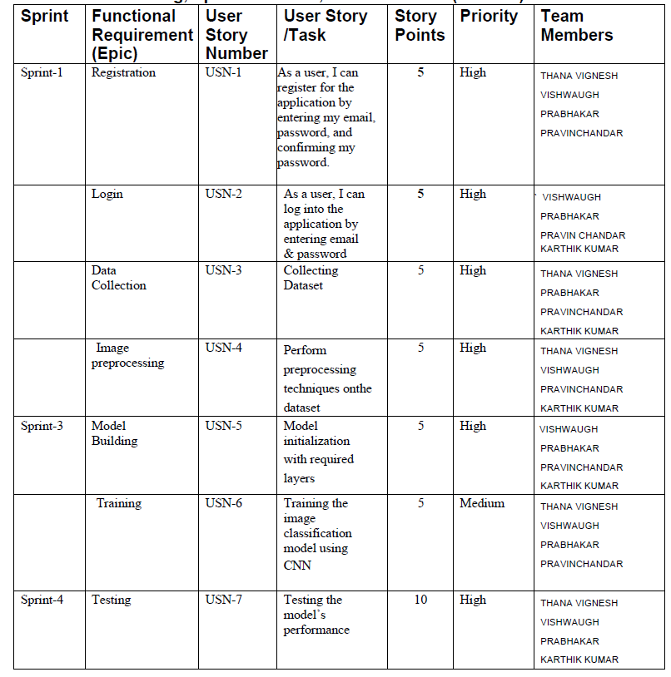

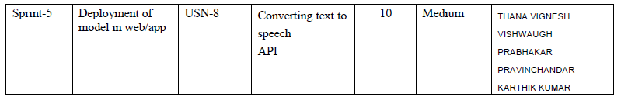

6.3 Reports from JIRA

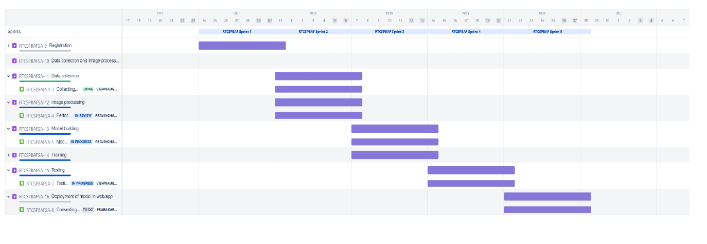

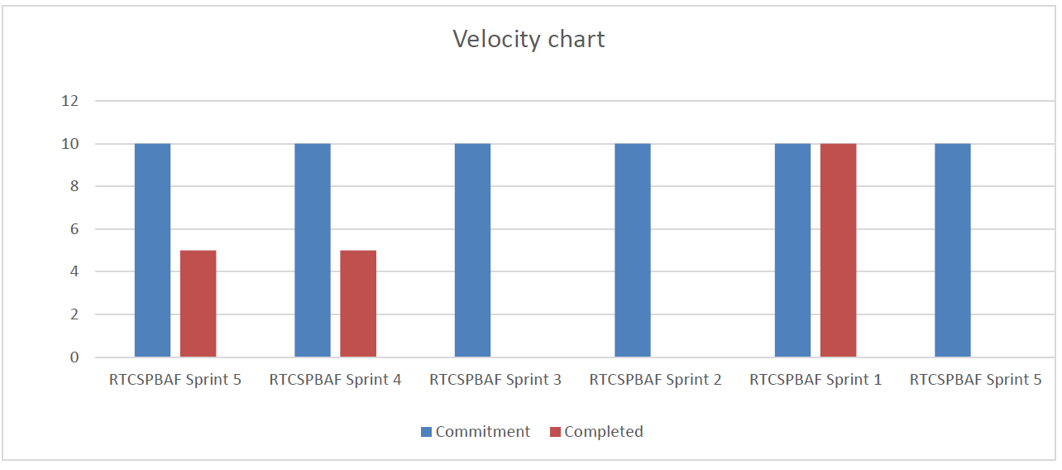

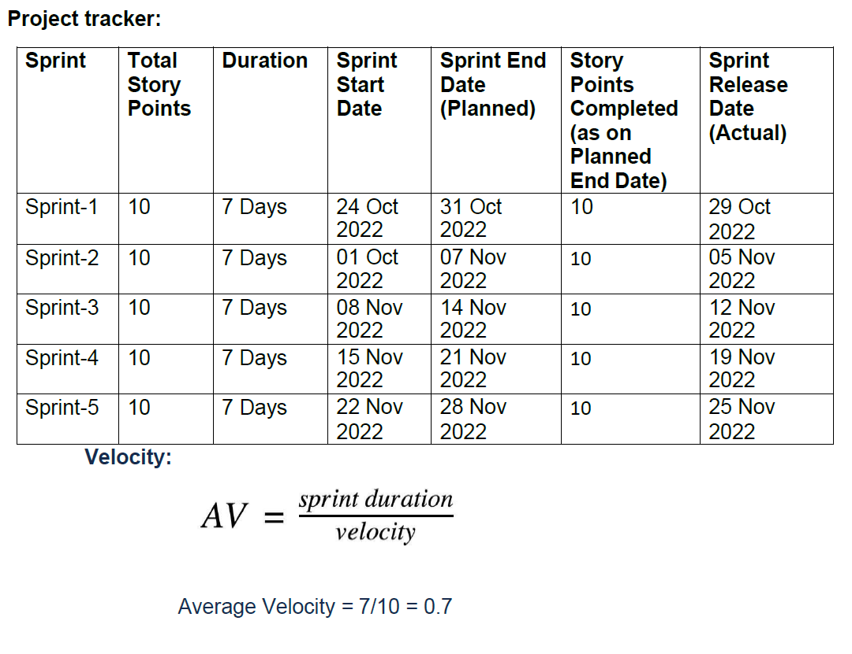

**7.CODING & SOLUTIONING (Explain the features added in the project along with code)**

**1.Model building**

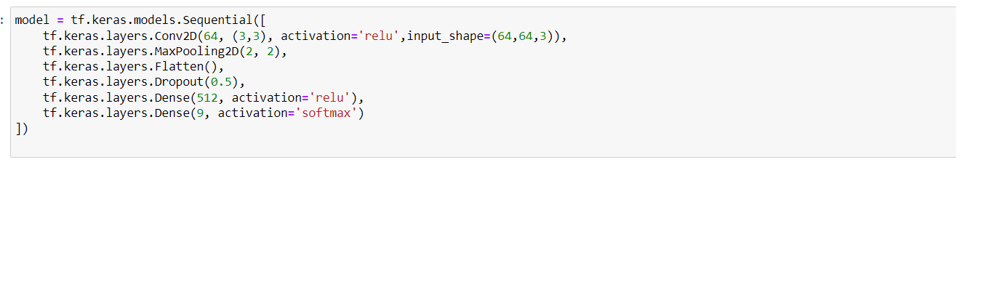

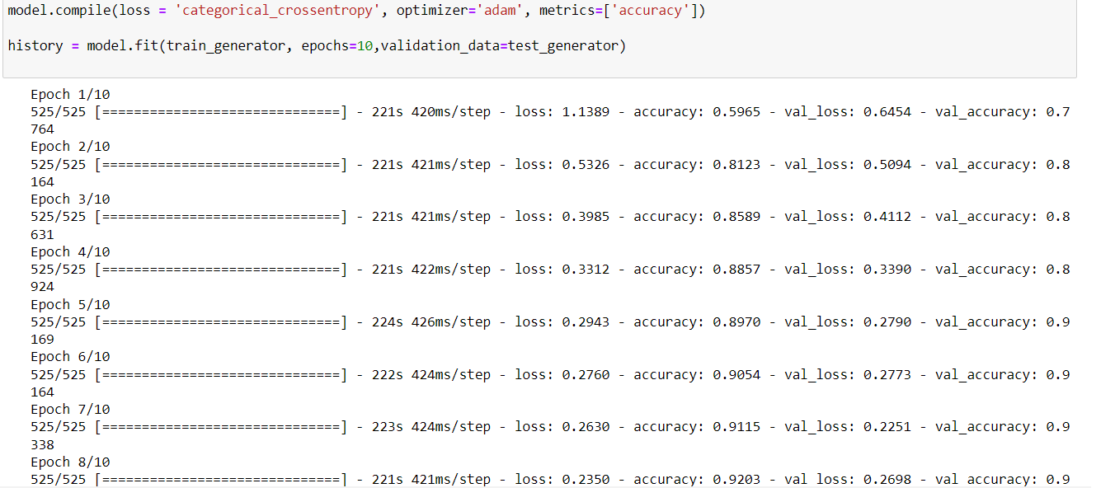

the model is built and trained on IBM cloud using sign language dataset with 9 classes (A to I)

2.FLASK APPLICATION DEVELOPMENT

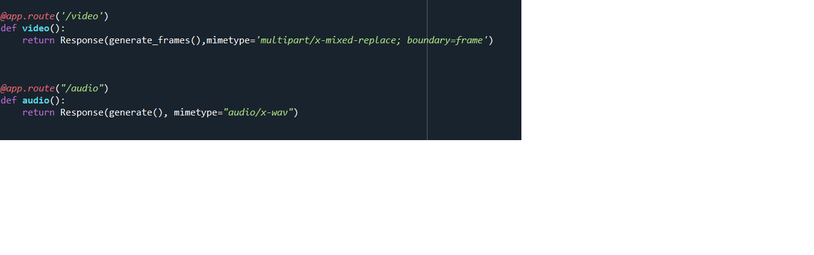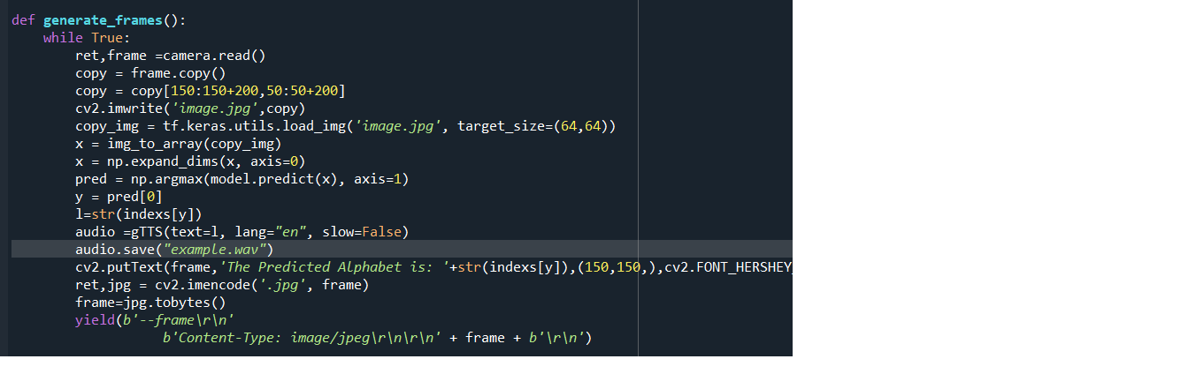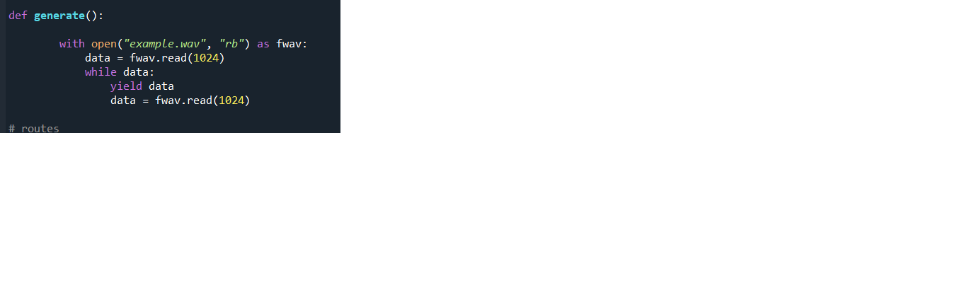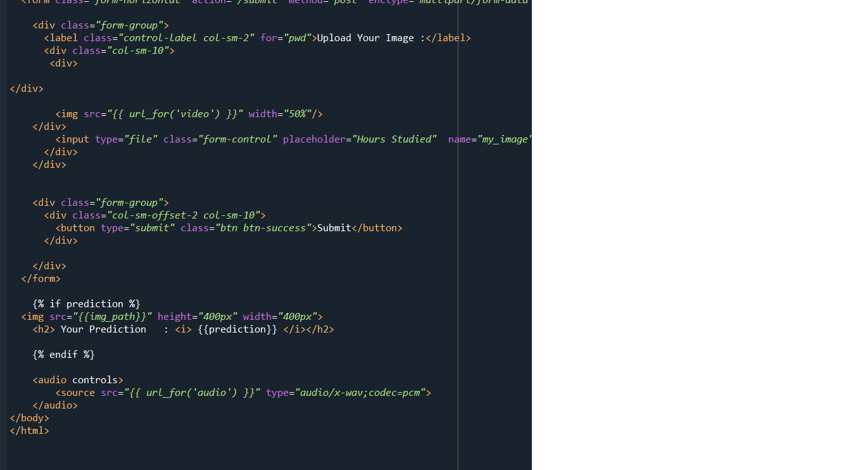

**1.Model features – prediction from live video**

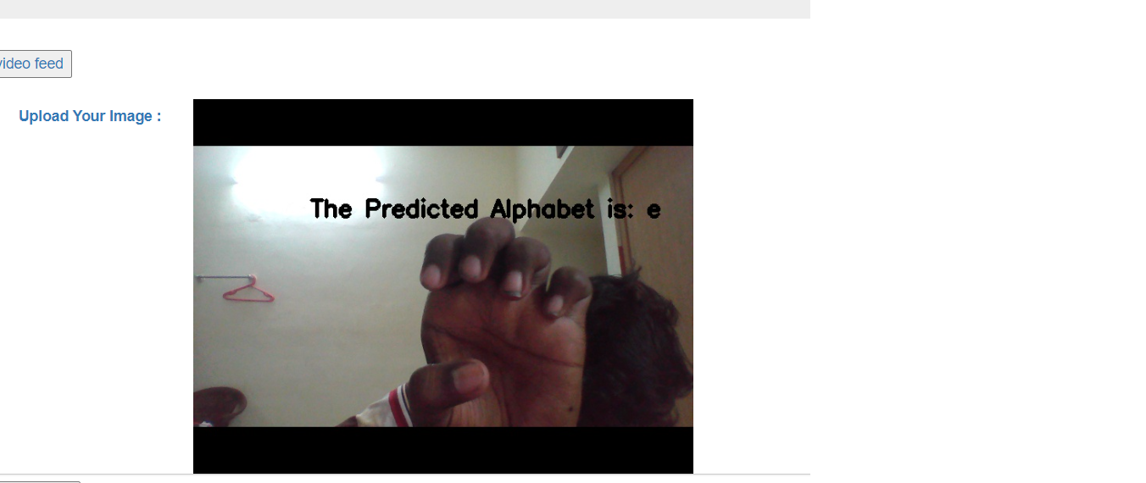

**2.prdeiction from uploaded image**

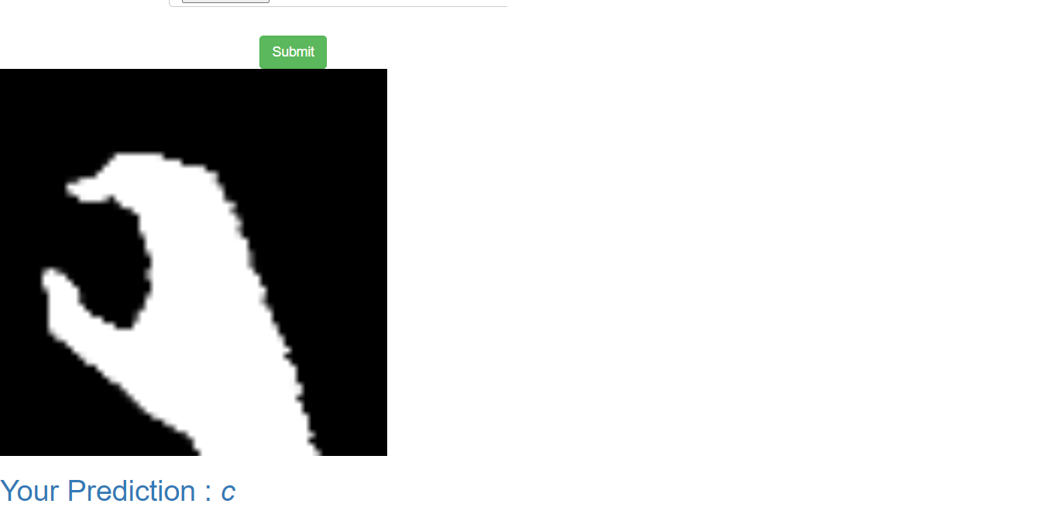

**8.TESTING**

**8.1 Test Cases**

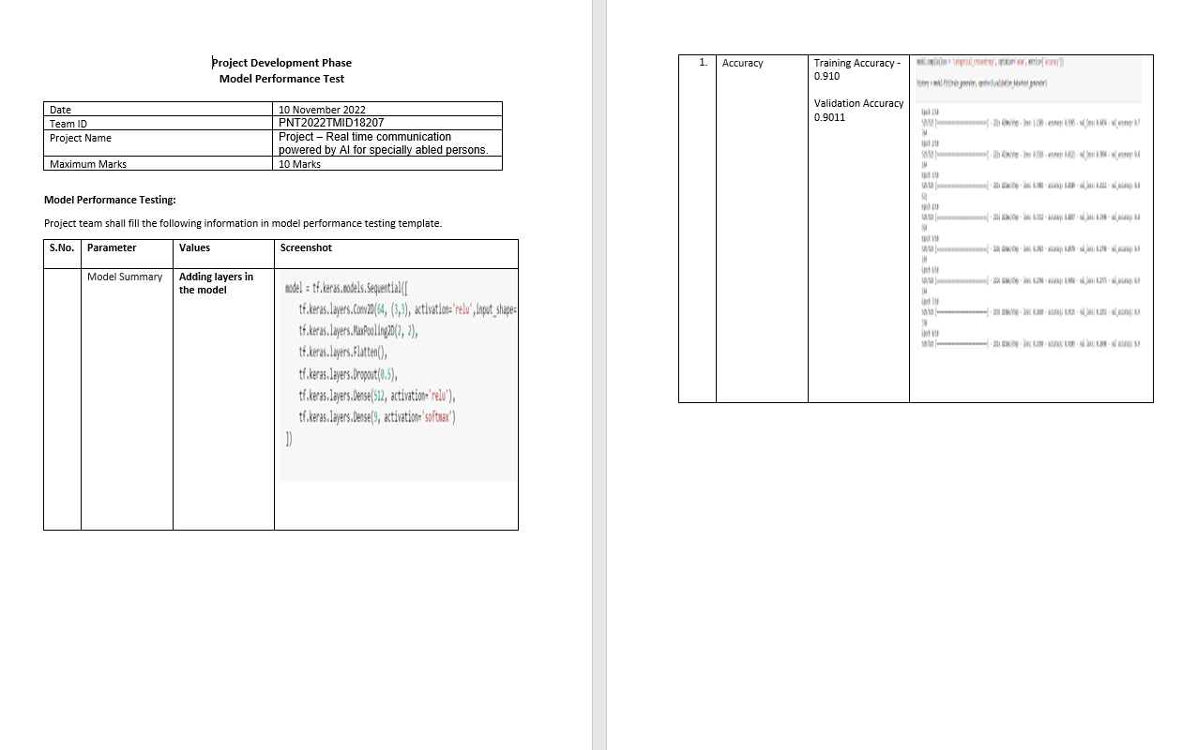

**8.2** User Acceptance Testing

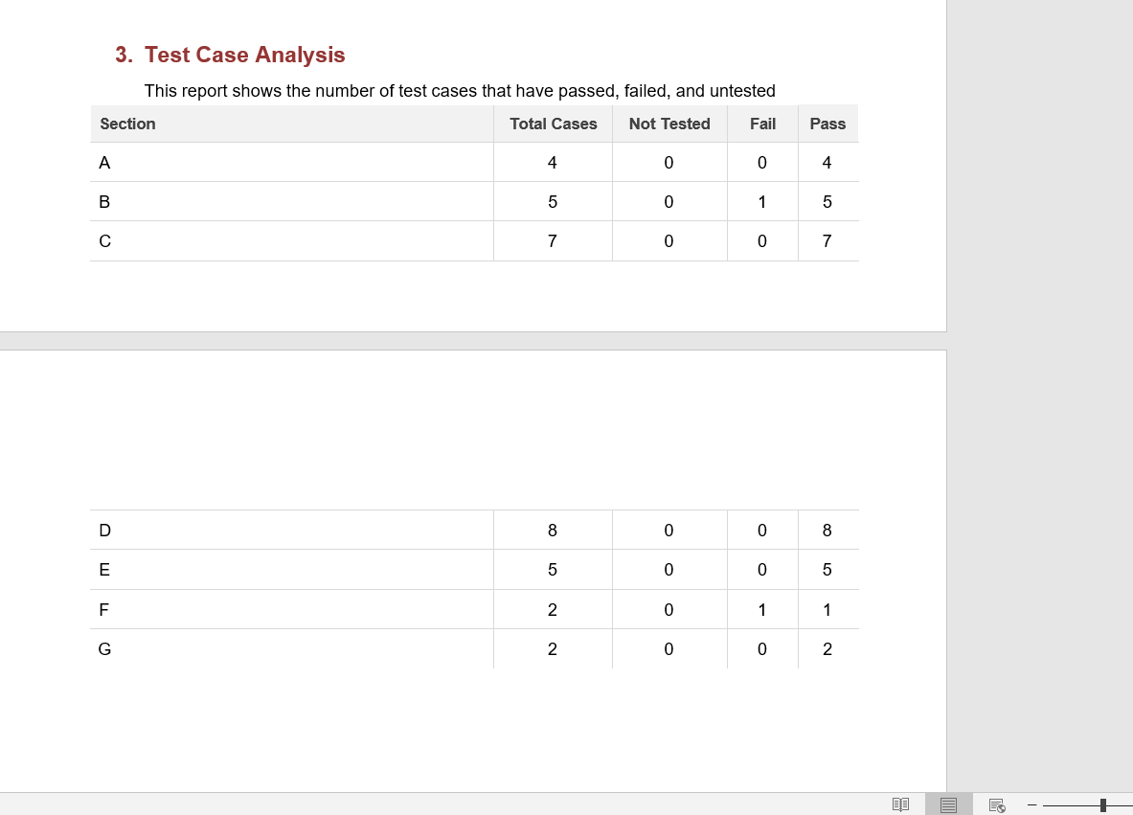

**9.Results**

The results on training accuracy were over 90 percent but testing on real world samples is not entirely correct there are misclassifications here and there so it needs to be rectified in near future to give valuable end product

**9.Advantages and Disadvantages**

The end user application can predict video give audio output

And prediction can also be done from uploading images

But model is yet to be trained further so misclassification is there and need to refresh everytime to get audio output

**10.Conclusion**

The real time communication system for disabled people is highly useful>our product serves as a prototype with minor bugs still it does it job It can be extended for large scale deployment with proper trained model with vase dataset and good app building

**11.Future Scope**

The model can be properly trained and good application can be developed deployed for real time use.

**11.GITHUB LINK AND VIDEO LINK**

[**https://github.com/IBM-EPBL/IBM-Project-2254-1658468105**](https://github.com/IBM-EPBL/IBM-Project-2254-1658468105)

[**https://github.com/IBM-EPBL/IBM-Project-2254-1658468105/blob/main/Project%20Development%20Phase/Sprint%204/final%20output/Screen%20Recording%20(17-11-2022%2023-44-52).mp4**](https://github.com/IBM-EPBL/IBM-Project-2254-1658468105/blob/main/Project%20Development%20Phase/Sprint%204/final%20output/Screen%20Recording%20(17-11-2022%2023-44-52).mp4)

**https://drive.google.com/file/d/1xkRBHHbBY23XxvbzIYyVJ-ekmijaQG6h/view?usp=sharing**